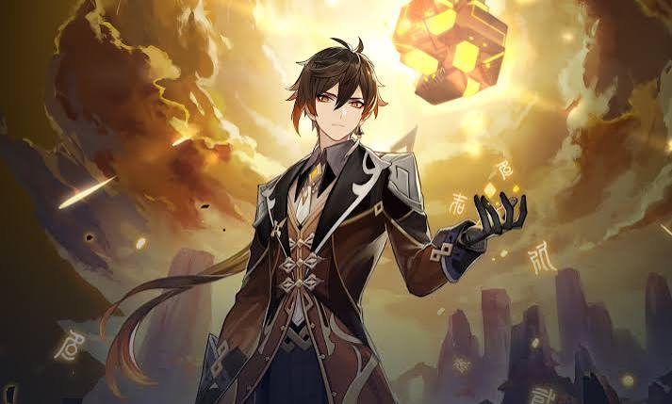
- Favorite Character: Zhongli
- Favorite Nation: liyue
- Favorite Element: Geo
- Favorite Weapon: Polearm
- Favorite Food: Bamboo Shoot Soup
- Favorite Quote: “Every journey has its final day”.

- My Hobby: Playing Genshin Impact
- My Favorite Color: Dark Blue
- My Dream: To visit Teyvat
- Why I like Zhongli: He is wise – calm and powerful

The Seven Archons of Teyvat

شماره | Archons | Element | Nation
1 | Barbatos(Venti) | Anemo | Mondstadt
2 | Morax(Zhongli) | Geo | Liyue
3 | Beelzebul(Raiden EI) | Electro | Inazuma
4 | Buer(Nahida) | Dendro | Sumeru
5 | Focalors(Furina) | Hydro | Fontaine
6 | Mavuika | Pyro | Natlan
7 | Tsaritsa | Cryo | Snezhnaya

A

